Loci
A locus (plural – loci) is a set of points which satisfy a given condition. The locus of a situation may be any shape, curve, or line, including circles and ellipses. The word ‘locus’ is derived from the Latin word for ‘place’. There are several important loci theorems.
Firstly, the locus of points which are a fixed distance (‘d’) away from a single point will be a circle with the radius as ‘d’. For instance, if you were asked to shade the area a goat can reach if it is tied to a spot with a 5-meter-long leash, the locus would be a shaded circle with a radius of 5 meters. All the points on the circumference of the circle are equidistant from the centre.
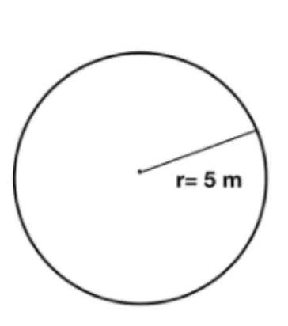

Secondly, the locus of points which are a fixed distance away from any two points will always be the perpendicular bisector of the line segment formed by joining the two points. For example, if you were asked to draw the locus of points which are equidistant from point A and B, you would draw the perpendicular bisector. Thus, every point on the bisector would be equally far apart from both A and B.
To construct a perpendicular bisector, you need to set the needle point of your compass to one end of the line. Then, open the compass to more than halfway between points A and B and draw an arc on either side of (above and below) the line. Without changing the compass width, place the needle point on B and draw two more arcs that intersect the ones you have already drawn. Draw a straight line connecting the points where the arcs on each side of the line meet.
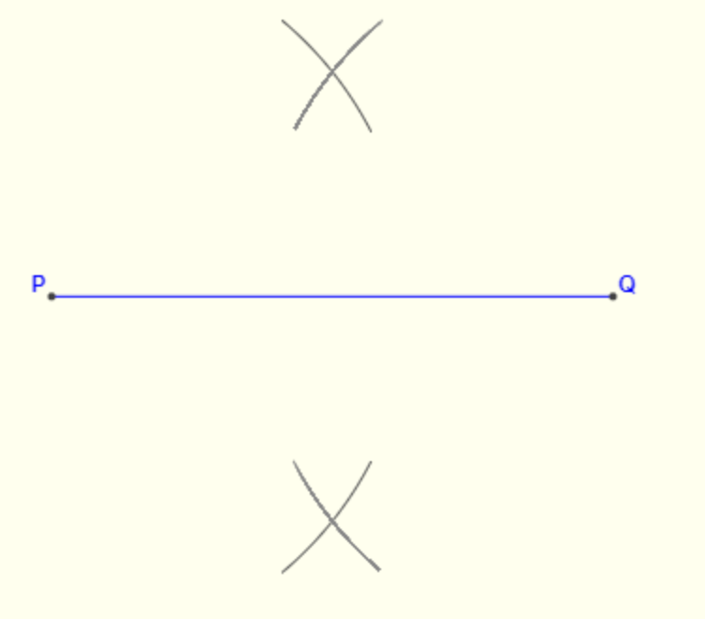

Constructing a perpendicular bisector
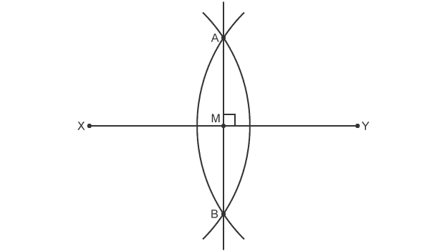

The locus of points equidistant from two points (X and Y) is line AB, drawn by constructing the perpendicular bisector of line XY
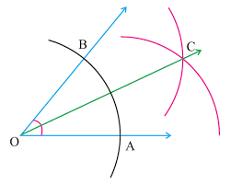
Thirdly, the locus of points equidistant from two fixed lines will be the angle bisector of them. If there is a pathway that constantly gets wider at a set degree, and you have to draw a line that’s equidistant from both edges, then you would need to use this theorem. Let the two edges be X and Y. The locus would be the angle bisector of angle XY.

To construct an angle bisector, you would need to place the needle of your compass on the vertex (O) and draw an arc that intersects both edges. Then place the needle on each intersection (A and B) and draw a second arc. Keep the width of the compass the same with both arcs. These last two arcs should intersect to form a point (C) on the center of the angle. If you draw a straight line between this point and the vertex, you will have completed an angle bisector and would have correctly drawn the locus.
There are other shapes formed by loci too. If you have to find all points equidistant from a straight line, the locus would be a pair of parallel lines on either side of the line, a fixed distance away, and a semi-circle on either end of the line with the radius as the fixed distance. If you have to find all points equidistant from a pair of parallel lines, the locus would be a straight line in between the two parallel ones.
Loci are useful when it comes to calculating points that obey a certain rule. They are very helpful in real-life situations too, which range from calculating planet orbits to finding the area required for a door to turn on its hinges.

