Cracking the Pi Code
Aryav Odhrani

3.14159265… Pi: ‘the numerical value of the ratio of the circumference of a circle to its diameter’, according to Oxford Dictionary. This number may be just a ratio, but it is an endless, irrational, and transcendental one with as many uses as its digits! But why is it so important, how was it calculated, and what are its uses in modern times?
History
The concept of pi has been around for over 4000 years! Initially, the number 3 was used in calculations involving the area of a circle. Progress was made in the great ancient civilisations of Babylonia and Egypt, where Babylonian mathematicians used $\frac{25}{8}$ (3.125), and in the Rhind Papyrus (mathematical scroll) of the Egyptian Middle Kingdom, the number $\frac{256}{81}$ (3.1605) was used.
However, the first breakthrough in accurately calculating pi was made in Greece (∼250 BC), by none other than the famous mathematician Archimedes. Using the Pythagorean Theorem, he was able to calculate pi accurately to 2 decimal places (3.14). Archimedes found the perimeters of two polygons, one fitting inside a circle, and one outside, giving him upper and lower bounds for the value of pi. As he increased the number of sides of the polygon, his approximations became more accurate. The mathematician, after reaching 96-sides, found that pi was between $\frac{223}{71}$ (3.1408) and $\frac{22}{7}$ (3.1428), the latter of which is still used today as an approximate fraction for pi’s value. Greek-Roman scientist Ptolemy continued Archimedes’ method to get the value 3.1416 around 150 AD.

The diagram shows the basic Archimedes method of finding pi.
Between 150 AD and 1600 AD, many mathematicians around the world independently obtained values of pi to varying degrees of accuracy. In China (480 AD), renowned mathematician Zu Chongzhi calculated pi to 7 digits ($\frac{355}{113}$), a record that held for 800 years. Other famous historical figures who calculated pi in various ways included Indian astronomer Aryabhata (∼500 AD), Italian mathematician Fibonacci (∼1200 AD), Italian author Dante (∼1300 AD) and Persian astronomer Jamshid al-Kashi (∼1400 AD). Al-Kashi calculated pi to 9 digits using calculations involving a polygon of 3x2²⁸ sides!
In the early 1600s, Dutch mathematician Ludolph van Ceulen reached 35 digits, which led to the number being called the ‘Ludolphian number’ in Germany until recently. After this breakthrough, mathematicians began to develop techniques called ‘infinite series’. This enabled them to reach greater levels of precision than possible with geometrical techniques when calculating pi. European mathematicians and scientists like Gregory, Leibniz, and Newton, as well as Indian mathematicians like Nilakantha and Madhava of Sangamagrama all created such series.
In the 1700s, William Jones began using the Greek letter π to represent the number, something which was popularised by Leonhard Euler.
A simple infinite series for π is the Gregory-Leibniz series:
$$π=\frac{4}{1}-\frac{4}{3}+\frac{4}{5}-\frac{4}{7}+\frac{4}{9}-\frac{4}{11}+\frac{4}{13}-…$$
Another more quickly converging infinite series is the Nilakantha series:
$$π=3+\frac{4}{2x3x4}-\frac{4}{4x5x6}+\frac{4}{6x7x8}-\frac{4}{8x9x10}+…$$
After 5 terms, the Gregory-Leibniz is within 0.2 of the correct value of π (at 3.34), whereas the Nilakantha series is within 0.002 of π (3.1396)
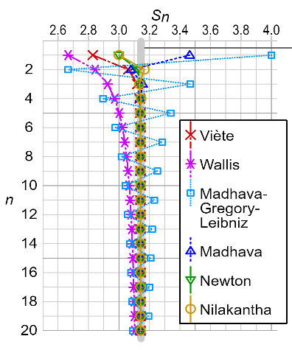
The image shows the convergence of infinite series for π, where Sn is the approximation of pi after finding the sum of n terms.
Uses
Pi has a plethora of uses in modern times. Almost anything to do with circles will be bound to involve π, whether it’s clocks, aircraft surfaces, fluid ripples or the structure of eyes!
In Science, many important formulae including statistics, mechanics, cosmology, number theory and electromagnetism use π. Researchers use π in their calculations to make breakthroughs in many different industries.
The automotive industry uses π to measure the circular velocity of wheels, motor shafts and engine gears, which are vital to the production of cars and planes.
In the space industry, NASA uses π to measure crates and the sizes of planets. Pi (as well as radius and mass) helps them calculate the density of an object like an asteroid, so they can find out what it’s made of (ice, rock, iron etc.). Furthermore, π is used by propulsion engineers to calculate the size of tanks and volumes of liquid propellant to keep spacecraft flying.
Pi is even used to calculate the size and volume of swimming pools in houses, water parks and hotels. The significance of π to circles means that it is used in many different ways in all aspects of life.

In conclusion, π is one of the most important mathematical constants to have ever been discovered. The value is used in many fields such as physics, engineering, and computer science. Pi can be traced back to ancient civilisations and has been calculated to many decimal places by various famed mathematicians over the centuries. Pi is essential to many mathematical and scientific calculations and applications and will continue to be an important part of our understanding of the world around us.

Sources:
allthescience.org, amazingarchimedes.weebly.com, arxiv.org, csmonitor.com, exploratorium.edu, mathshistory.st-andrews.ac.uk, oxfordreference.com, thevarsity.ca, wikipedia.org, universetoday.com

