The Monty Hall Problem

The Monty Hall Problem is a classic brain teaser in the form of a puzzle. It was named after the host of the game show, Let’s Make a Deal, from where the puzzle originated. Monty Hall would present three closed doors. Two of them would contain a goat, while one would have a sports car. The contestants would have to choose a door, after which Hall would open another door. The host knows where the car is, so he always opens a door with a goat inside it. The player is then left to the option of staying with the door he or she has chosen or switching to the remaining door. If the door the player chooses the door that has the car, then they can take it with them. The choice of switching or staying is the confusing part.
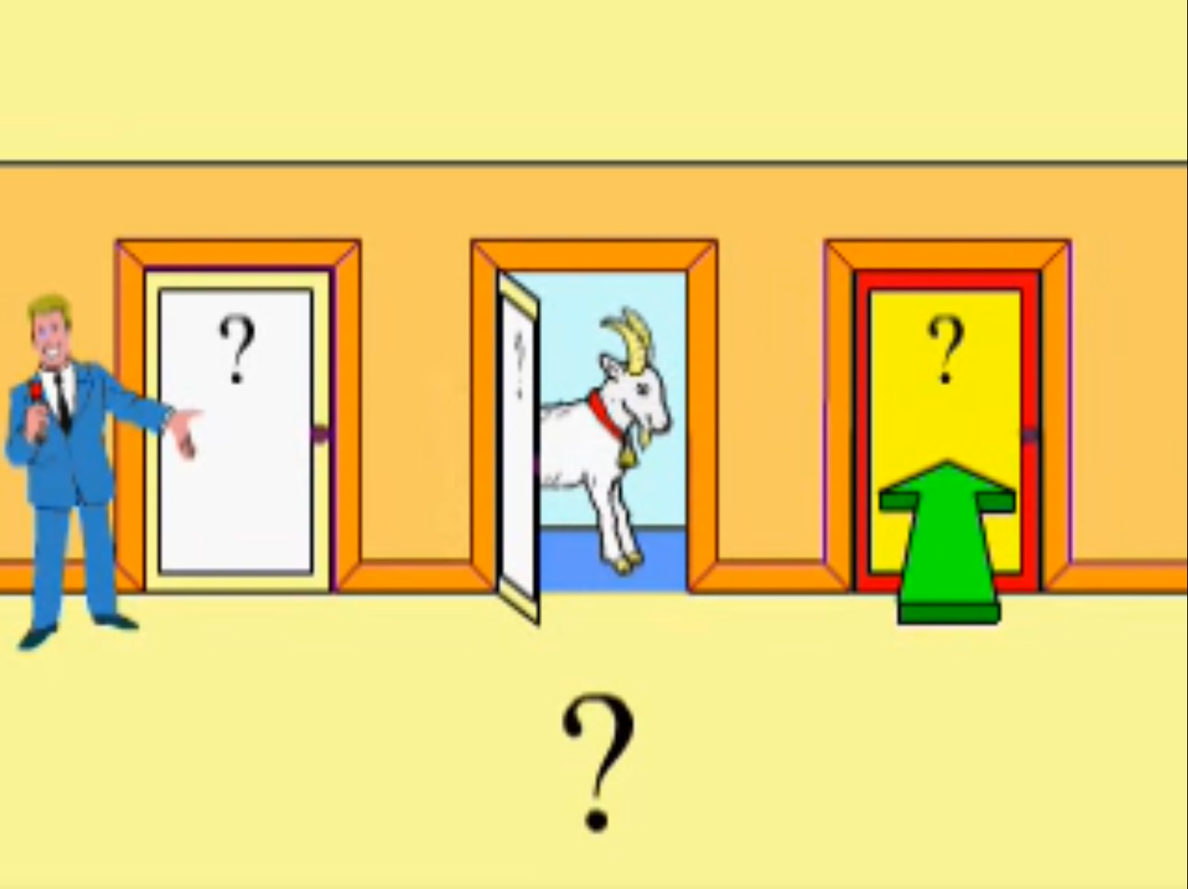

Most people think that there is no difference between switching or staying because after the host opens a door, one of the remaining two doors has a car, and the other has a goat. People think that this gives them a 50% percent chance of getting either. However, mathematics shows that the strategy is to always switch, as this would benefit you in the long run. The reasoning behind this is as follows.
If you pick door number one, then there is a 1 in 3 doors chance ($\frac{1}{3}$ chance) that you are correct, and a $\frac{2}{3}$ chance that you are incorrect. Say the host exposes door two, then there is only door one and door three left. The $\frac{2}{3}$ probability that lied in doors two and three concentrates at the door the host didn’t choose (door three). Thus, if you swap to door three, it will be twice as likely (a 66% chance) that you will get the car. If you play multiple times, switching will benefit you in the long run.
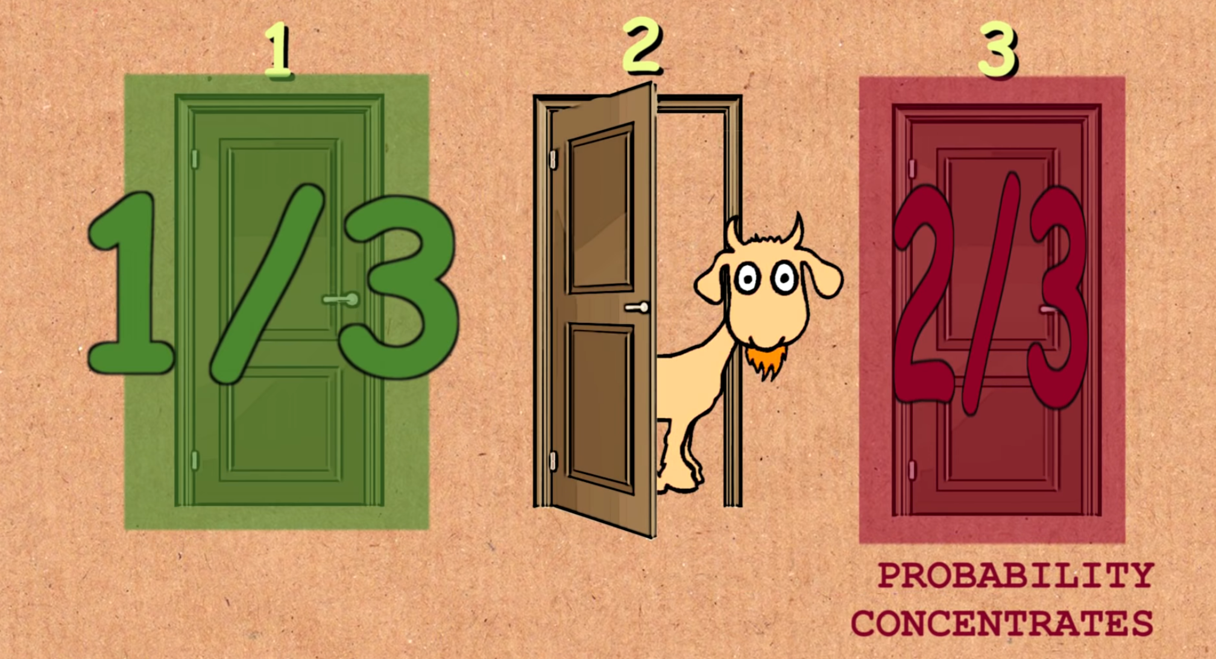

To make this easier, you can imagine the same concept with a hundred doors. If you choose door one, and Monty exposes all of the other doors except for door thirty-seven, the $\frac{99}{100}$ chance that lied in doors two to hundred all concentrate behind door thirty-seven.

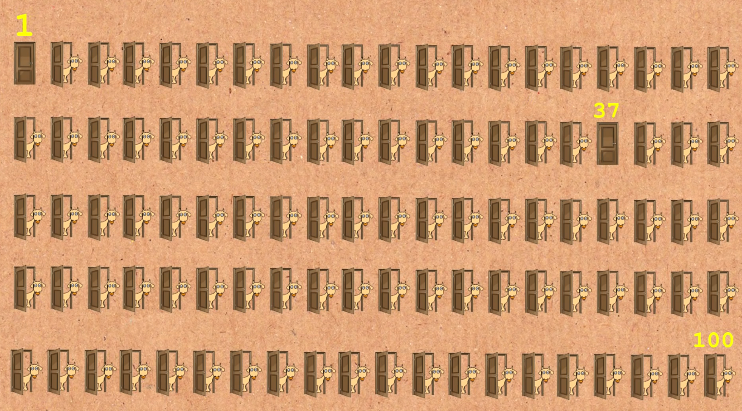
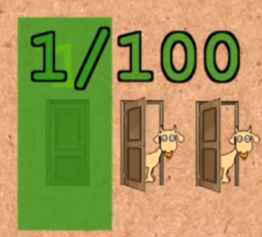
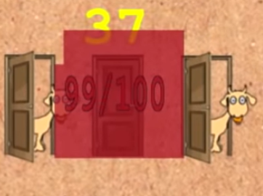

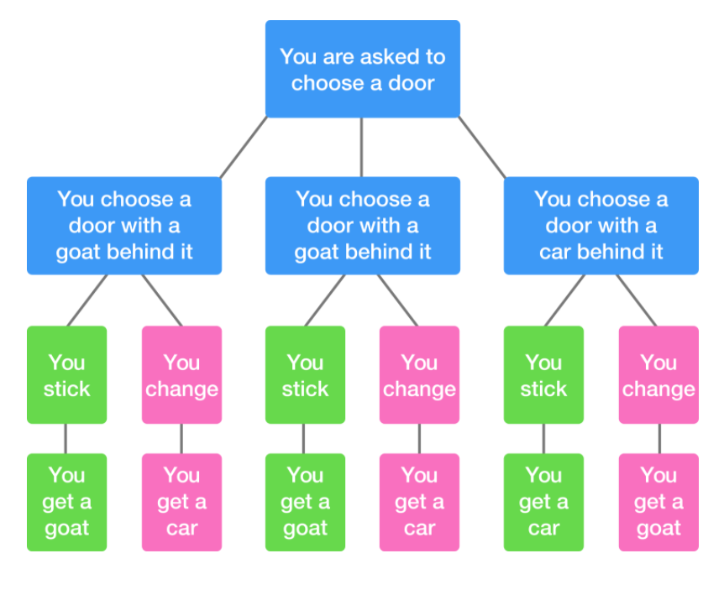
It is also clear that switching results in more wins by looking at a diagram of possible choices. The tree below shows that $\frac{2}{3}$ of the pink (changing) gives a car, while only $\frac{1}{3}$ of the green (sticking) gives the prize.

To learn more about the Monty Hall problem using Bayes’ Theorem, you can visit this website.

Sources:
- Wikipedia
- Numberphile
- Khan Academy
- Niansenx
- Brilliant.org

